St. Lucy/St. Sebastian High School Religious Ed. Registration (9th & 10th Grade)
2023-2024

Please Print

Student First Name_________________________Student Last Name________________________________

Student Birthdate__________________________ Family Last Name ______________________________

School Attending ______________________________________Grade on Sept. 1, 2023____________________

**Family Email Address__________________________ Student Email________________________________

Street Address ________________________________________________________________________________

City _____________________Zip Code _______________________ Phone # ______________________________

Father’s Name ______________________________________Religion ___________________________________

Mother’s Name ___________________________Maiden Name _________________Religion____________

Mom’s Cell # ____________________________ Dad’s Cell # ___________________________________
Student Cell #_______________________________ Cell Phone Provider___________________

Mother’s work #________________________ Father’s work # ________________________

What is the best way to get info information to you (circle one): Email, Call, Text

What is the best way to get info. to the student (circle one): Email, Call, Text.

Emergency Contact _____________________________________ Phone #_________________________

Are Parents Divorced _____________Student lives with _______________________________________

List any Special Needs: ( ADD, ADHD, physical restrictions, allergies, medications) __________________

More information on reverse side

Sacraments Received

Date Name of Parish City, State

Baptism_______________________________________________________________________

First Holy Communion ___________________________________________________________

Current Fees
High School CCD program……………………………$80.00

Classes will be held at St. Lucy Church Sunday nights from 6:00 PM - 7:30 PM
Students will be asked to hand in their cell phones at the beginning of each class. They will get them back at the end of class.

All students are strongly encouraged to come to 5 PM Mass on class dates.

All students are obligated to attend one retreat in their 9th and 10th grade years. These will be setup by Eric.

Please contact Eric Antrim (Director of Youth Ministry) with any questions.
eantrim@stlucychurch.org
262-554-1801 Ext. 205 Cell # 262-498-9028
Make Checks Payable to: St. Lucy Church

Amount Due: _____________ Date Paid:__________________

Due by Sep. 20th 2023
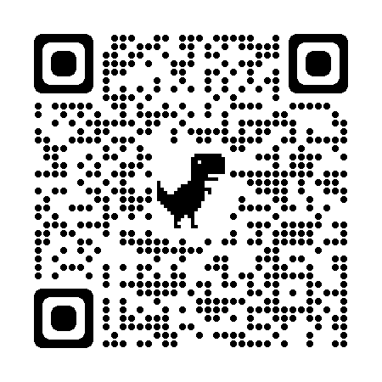 Scan to fill out online

